**EXPERIMENT 10**

**TRIGGERS**

**Aim:**

* Create a table with attribute sname, and another table with newname.
* Create a trigger to insert into second table before inserting in first table.

**create table test_tr(name varchar(30));**

**create table test_tr2(newname varchar(30));**

**create trigger before_test_update_tr**

**before insert on test_tr**

**for each row**

**insert into test_tr2**

**set newname = new.name;**

**insert into test_tr values('Arjun');**

**select *from test_tr;**

**select * from test_tr2;**

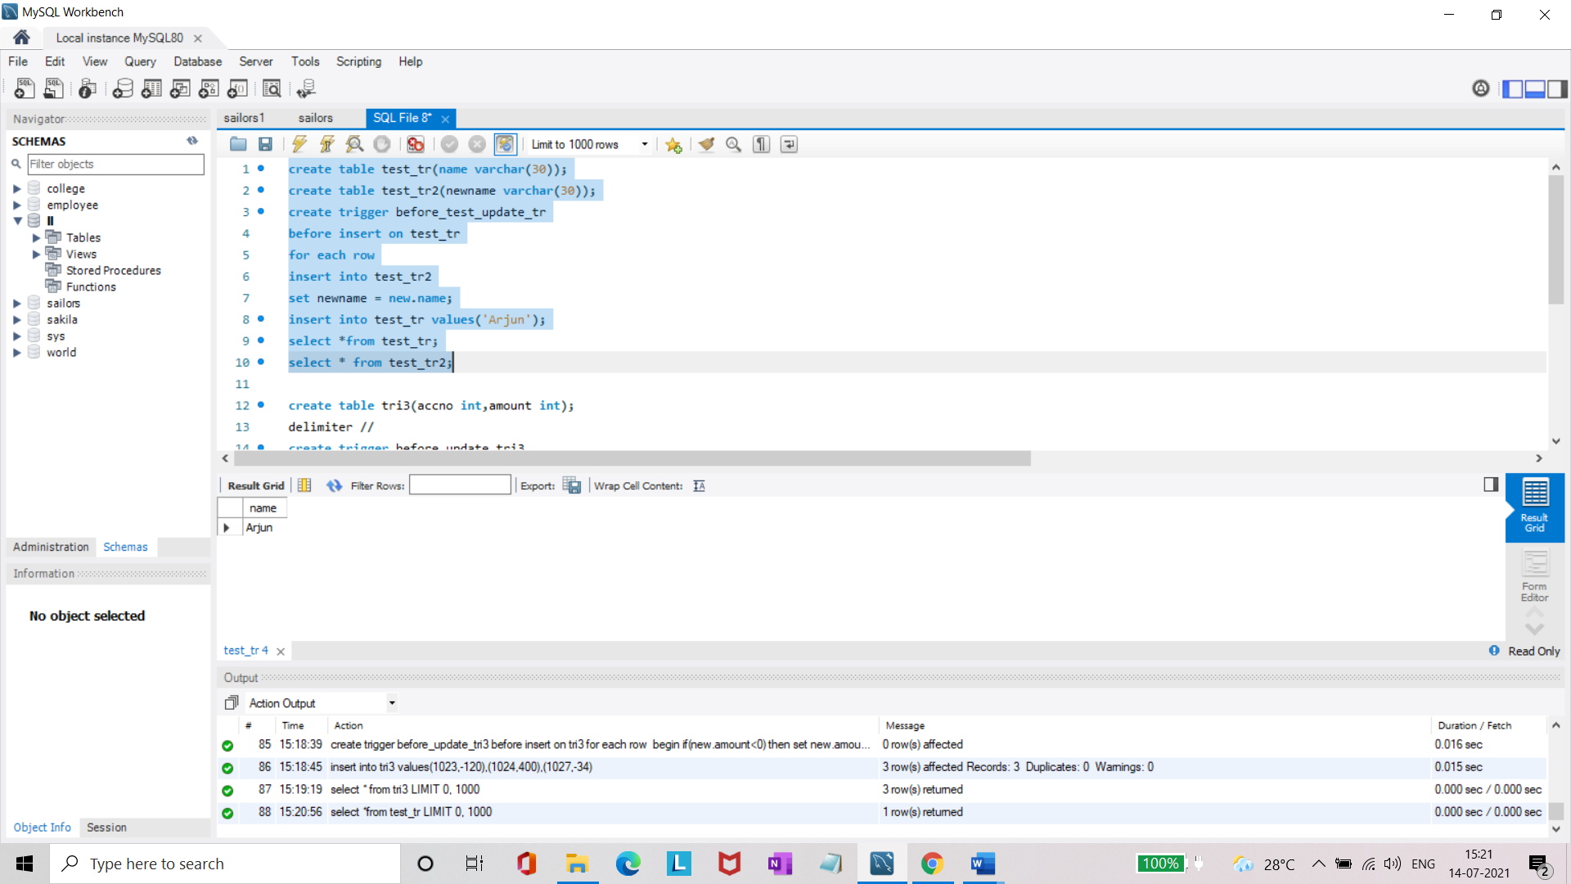

* Create a table for account details with attributes account number and an amount.
* Create a trigger to check if amount is negative or greater than zero before inserting to table.

**create table tri3(accno int,amount int);**

**delimiter //**

**create trigger before_update_tri3**

**before insert on tri3**

**for each row**

**begin**

**if(new.amount<0) then**

**set new.amount = 0;**

**elseif(new.amount>100)then**

**set new.amount=100;**

**end if;**

**end; //**

**delimiter ;**

**insert into tri3 values(1023,-120),(1024,400),(1027,-34);**

**select * from tri3;**

